20.18: For the smallest amount of electrical energy, use a Carnot cycle.
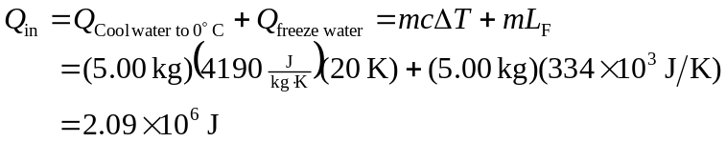
Carnot cycle: 